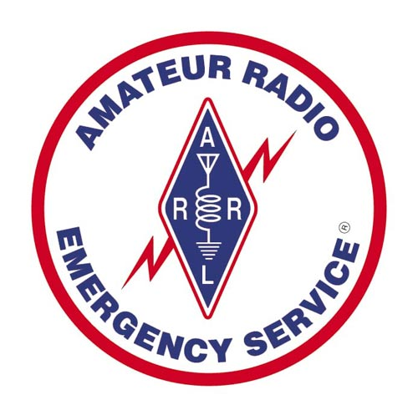

***Amateur Radio***

***Emergency Service***®

***Eastern New York Section Emergency Plan***

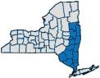***Trademarks***

Amateur Radio Emergency Service® and ARES® are registered trademarks of the American Radio Relay League, Inc. and are used by Permission.

The Amateur Radio Emergency Service® symbol is a trademark of the American Radio Relay League, Inc. and is used by Permission.

All third-party trademarks are property of their respective owner.

## Revision Log

Please indicate here all revisions to the plan.

Draft Document 0.1 November 1, 2011 KM2O

Draft Document 0.5 January 18, 2012 KM2O

Draft Document 0.9 February 9, 2012 KM2O

Release Document 1.0 February 17, 2012 KM2O

Draft Document 1.1 June 24, 2022 WA2IWW

Release Document 1.2 November 7, 2022 KM2O

## Plan Distribution

The following individuals/agencies/departments shall receive copies of the plan.

### Eastern New York Section Manager

* Eastern New York Section Emergency Coordinator
* Eastern New York District Emergency Coordinators
* Eastern New York Emergency Coordinators
* Eastern New York Section Traffic Manager
* Eastern New York Public Information Coordinator
* New York State RACES Radio Officer
* Served Agencies

This plan and any updates will also be available online at:

<http://enyares.org> or <http://eny.arrl.org/ARES>

## Table of Contents

Trademarks 2

Revision Log 2

Plan Distribution 2

Table of Contents 3

Introduction 4

Purpose 6

Situation and Assumptions 7

Operations 9

Activation Procedures 12

Mobilization 13

Resources 14

Operational Protocols 17

Drills, Organization and Training 19

Acknowledgements and Approvals 21

Appendices

1. Glossary of Terms
2. ENY Section Emergency Nets
3. EC Contacts
4. ENY Section Traffic Nets
5. Resources and References
6. ARRL ARES® Plan

### *1. Introduction*

1.1. The Eastern New York Section Amateur Radio Emergency Services (ARES®), herein called ENY ARES® for brevity, is comprised of FCC-licensed amateur radio operators who have voluntarily registered their capabilities and equipment for the purpose of Emergency and Public Service communications. These individuals are registered with the American Radio Relay League’s (ARRL) ARES®; they may also be registered with other agencies as well.

1.2. The ENY ARES® functions under this Emergency Plan at the direction of the Section Emergency Coordinator (SEC), who is appointed by the Eastern New York Section Manager (SM).

1.3.The Eastern New York Section of the ARES® consists of 15 counties of the state. The Section is further divided into 4 Districts as indicated in the table below. See Section Map section 1.5. Below.

**Northern District Central District** **Southern** **District**

Albany Columbia Orange

Rensselaer Dutchess Putnam

Saratoga Greene Rockland

Schenectady Ulster Sullivan

Warren Westchester

Washington

**State EOC**

**(See 1.6. Below)**

State Campus, Albany

1.4 Local ARES® groups are usually formed at the county level and each should have their own Emergency Communications plan. Districts should also have a plan for events that effect more than one county and should support inter-county operations. The Section plan supports the local and District levels. This plan is written with the Section in mind; however, most of the principles can be applied at the District and local levels for those county ARES® groups that do not have a local or District plan.

* 1. Section Map

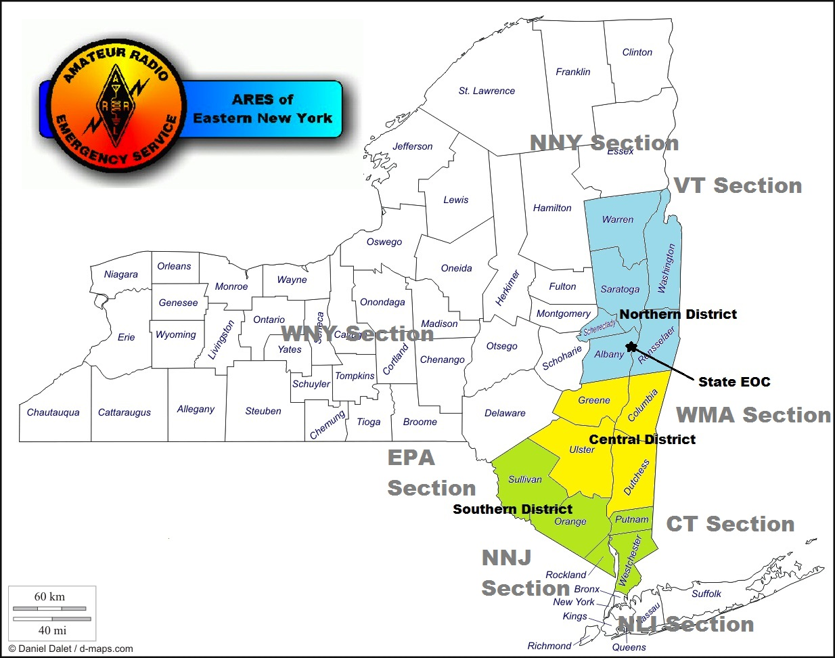

### 1.6. Consistent with the principle of ARES® and RACES as a unified amateur radio response, State EOC is a district geographically located in the Eastern New York Section for administrative and support purposes. However, State EOC will be considered an independent statewide resource. Due to security and insurance limitations, operational access to the State EOC amateur station is limited to current State employees holding valid amateur radio licenses. The roster of current state employees with amateur radio licenses will be considered dual ARES® and RACES members of State EOC and are able to operate the EOC facilities seamlessly. The District Emergency Coordinator (DEC) of State EOC is the State RACES Radio Officer. *2. Purpose*

***ARES® Vision Statement***

*The Amateur Radio Emergency Service®, a program of the ARRL, offers to the public and to its partners at all levels trained Amateur Radio Service licensees who are skilled in the use of a wide range of emergency and disaster communications techniques and who are committed to supporting our partners’ missions in service to the public. (ARRL ARES® Plan)*

***ARES® Mission Statement***

*The Amateur Radio Emergency Service**® (ARES®), a program of ARRL, the national association for Amateur Radio®, is comprised of organized, trained, and identified Amateur Radio operators who augment and support vital communications on behalf of the public through partner agencies and organizations during emergencies and disasters. The Amateur Radio Emergency Service®, through its volunteer radio communicators, strives to be an effective partner in emergency and disaster response, providing the citizenry and public service partners at all levels with radio communications expertise, and capabilities of professional communicators. (ARRL ARES® Plan)*

2.1. The purpose of this plan is to implement Part 97.1 of the Rules of the Federal Communications Commission (FCC) and to provide a written guide containing the minimum information that would be needed in an emergency. Each emergency is different and the flexibility to provide an adequate response to each is a necessity.

Note: References to ARES® working with EMA offices and officials is not meant to override the RACES organization which exists by legislation, instead it is implied that ARES® and RACES should be working together and as one, even if separate EC’s and RO’s are present. County EMA Directors and local municipal EMA Directors are welcome to adopt this plan for their own use.

2.2. The plan is designed to provide a basic outline of the resources and operations of the ENY ARES®.

2.3. The ENY ARES® provides emergency communications and can provide adjunct communications should conditions require. Our operational area is the Eastern New York Section, however, we are available where needed as so activated and authorized.

2.4. Each County Emergency Coordinator (EC) and District Emergency Coordinator (DEC) are required to develop their own local emergency plans for their respective jurisdiction. Such local emergency plans shall incorporate this document by reference and shall also be incorporated as annexes to this plan.

2.5. All Memorandums of Understanding, Emergency Plans and other related documents for local jurisdictions must be on file with the respective DEC, the SEC, the SM and the ARRL so that resource allocations and planning can be established. Additionally, all documents are subject to review and approval processes.

2.6. This plan, when activated, will work in close cooperation with all ARRL section level Field Services appointees as appropriate.

***3. Situation and Assumptions***

3.1. Hazards and disasters fall into three categories: natural, technological and terroristic.

Natural and technological disasters can include:

Tornado Power Outage Flood and Flash Flood

Severe Winter Storm Hurricane Mudflow/Landslides

Earthquake Dam Failure Hazardous Material Accident

Major Fire Aircraft Crash Nuclear Plant Accident

Chemical Release

Although many of the disasters listed above may not affect the entire community there is a cascade effect which occurs because of the strain on the infrastructure. Consider the following:

|  |  |
| --- | --- |
| **SERVICE** | **EFFECT** |
| **transportation** | **• inability to get emergency service personnel into the affected area**  **• inability to transport victims away for the area** |
| **electrical** | **• increased risk of fire and electrical shock**  **• possible disruption to transportation system if downed lines are on roads** |
| **telephone** | **• lost contact between victims, service providers and family members**  **• system overload due to calls from or to friends or relatives** |
| **water** | **• disruption of service to homes, businesses and medical providers**  **• inadequate water supply for fire fighting**  **• increased risk to public health is there is extensive damage to the water supply or if it becomes contaminated** |
| **fuel supplies** | **• increased risk of fire or explosion from ruptured lines**  **• risk of asphyxiation from gas leaks in confined spaces or using heating or cooking stoves with inadequate ventilation** |

* 1. In order to better prepare, it is necessary to make some assumptions. These assumptions then allow us to plan and prepare for these situations.

Therefore, you must assume:

• **A DISASTER WILL HAPPEN IN YOUR COMMUNITY**

• A disaster can, and in many cases does, occur without warning

• Disasters can occur at any time and families may be separated when the disaster strikes

• When a disaster occurs local emergency services will not be able to respond to every call for assistance

• Some situations may cause parts of the community to become isolated from others

• Outside assistance will not be available for at least 72 hours

• The telephone system may become disrupted

• Electricity may become unreliable

• The water system may be disrupted and/or the water undrinkable

• The local emergency services and hospital will not be capable of handling a sudden number of injured people

3.3. In some instances, such as weather-related problems, there may be advanced warning. Understanding the warnings and taking appropriate action at that time can save lives.

3.4. Since the assets of ARES® consist of individuals and their equipment it is extremely unlikely that any event would completely prevent ARES® from operating. However, ARES® members should be aware of events that can occur in the event of a disaster and the importance of always being prepared. ARES® members should make sure that their family is also prepared and have the necessary supplies on hand.

### *4. Operations*

* 1. ENY ARES® operates under the “lead agency” principal. This means the local ARES® group responds to requests from the agency that has the authority under local, county or state legislation to provide the lead in response to an emergency or disaster. In most instances this will be the local county emergency management agency (EMA). By following this guideline, amateur radio resources are coordinated through the local EMA and any conflicts for the resources are decided by EMA officials who are in a better position to prioritize communications needs.
  2. The National Incident Management System (NIMS) provided by the U.S. Department of Homeland Security (DHS) sets the expectation that emergency responders organize according to a national standard making it possible for all participants to work together in all aspects of an incident. Personnel and organizations that have not been trained in the common NIMS framework are, from a practical standpoint, not considered capable of being of assistance.
     1. ENY ARES® is expected to have an Incident and Command Management Organization that governmental emergency managers and first responders in the field can easily recognize and join. In emergency situations ENY ARES® serves that purpose by having various section officers and appointees assume emergency response duties. Each local ARES® should adopt an emergency structure that conforms to the NIMS standard also.
  3. Local EC’s should have a memorandum of understanding (MOU) with their local EMA or at least provide them with contact information. Any MOU should include conditions under which the local group would operate as ARES® or as RACES. A draft MOU must be reviewed by Section and ARRL HQ prior to signing.
  4. The Section should have a memorandum of understanding (MOU) with the state EMA and major served agencies within the section or at least provide them with a copy of this plan and contact information.
  5. The EC of each county ARES® group shall be responsible for maintaining an Emergency Plan for that group. Such plan shall, at a minimum, include contact information for EC and AEC’s, a notification and alerting plan for members, frequencies to be used and types of anticipated emergencies. The plan shall reference and become an annex to this document as well as any District Emergency Plan (if one exists).
  6. In any emergency it is essential that there be an orderly and controlled response. ARES® must be part of that response and function within, and abide by, the lead agency’s emergency plan. It is essential that we remember that we are there to provide communications for those agencies responding to the disaster.
  7. ENY ARES® may establish and maintain an online database of amateur radio operators who have voluntarily requested to serve in times of communication emergencies. The database will constitute a formal record of each volunteer’s demonstrated radio communication performance capabilities, education courses successfully completed, and stated personal deployment requirements so that assignment of individual operators to emergency deployment missions can be made. When higher level requests for emergency communication augmentation are received by the Section, this roster will be the **only** document from which deployment selections will be made. The database is a validation process for the requesting agencies to know the qualifications of each deployed volunteer amateur radio operator.
  8. Each local ARES® group may be activated only by the local EC or AEC or their designee.

* 1. Each local ARES® group may answer local requests for emergency communication augmentation received from local government emergency managers or non-government organizations utilizing unit resources according to their own response plan. All responses must be reported through the section chain of command and will become under the management and control of district or section staff if and when the emergency escalates geographically to a scale that breeches local unit service boundaries. Local EC’s are strongly encouraged to have their members register into the ENY ARES® online database. These confidential rosters of unit members that indicate which members have voluntarily requested to serve in emergency situations, document those member’s demonstrated performance capabilities and provide an educational record so that effective response planning can be made. It is understood by everyone, that when the emergency condition arises and help is requested, we will use ENY ARES® registered members first, from local, district and section availability. Within the local venue, non-registered members can be utilized only after completing intake processing.
  2. Should ARES® members become aware of a communications emergency, they should make every attempt to contact the EC or AEC to ensure she or he is aware of the situation.
  3. **ARES® members should not respond to any emergency or request from any agency unless the EC or AEC (or in their absence the SEC or SM) has authorized deployment of ARES®.**
  4. Once the local ARES® group has received a request the EC should attempt to notify the DEC and/or SEC as soon as possible. This will facilitate any request for additional assistance from other ARES® groups in the Section.
  5. The following individuals and agencies have authority to activate ENY ARES® and mobilize personnel and resources on a Section basis:
     1. Eastern New York Section Manager (SM)
     2. Eastern New York Section Emergency Coordinator (SEC)
     3. In the absence of above officials, their successors or designates.

4.13. The following individuals and agencies may request activation of ENY ARES® through the above officials:

4.13.1. Eastern New York District Emergency Coordinator (DEC)

4.13.2. Eastern New York Emergency Coordinator (EC)

4.13.3. Eastern New York Official Emergency Stations (OES)

4.13.5. New York State Division of Homeland Security and Emergency Services (DHSES) Office of Interoperable & Emergency Communications. (State RACES program)

4.13.6. National Weather Service (SKYWARN Program)

4.13.7. The Department of Homeland Security (DHS), FEMA or other designated agency under the Federal Response Plan

* + 1. Any agency that has an existing MOU with ARRL (i.e. American Red Cross, National Weather Service, Salvation Army, etc.)

4.13.9 Any other agency requiring communications assistance when deemed

appropriate by the above officials

### *5. Activation Procedures*

5.1. An EC, DEC, OES or their designee (hereinafter referred to as Appointee) who for any reason suspects that a communications emergency exists, or suspects that an adjunct communications need exists should monitor the assigned net frequency for activity. Net frequencies are listed in Appendix B.

5.2. Appointees may be alerted by a regularly scheduled emergency or traffic net.

5.2. Appointees monitoring the frequencies may be alerted by activation of an Emergency Group Call.

5.3. Appointees may be alerted by telephone call-up. (telephone tree)

5.4 Appointees may be alerted by SMS text message or other electronic means.

5.4. Appointees may be alerted by listening to announcements from an Emergency Alert System (EAS) station, NWS Weather Radio or Wireless Emergency Alert (WEA).

### *6. Mobilization*

6.1. Upon awareness that an emergency exists, members of ARES® shall check-in to the local ARES® Emergency Net and await instructions.

6.2. The EC or designee will become the Net Control Station (NCS).

6.3. The net shall be operated from the most appropriate location.

6.4. The NCS will be the focal point of operations, unless sub-nets are authorized by the EC, or NCS.

6.5. The EC or designee will assign specific duties to members as required by prevailing circumstances.

6.6. The EC or designate will request assistance from the DEC, SEC or outside agencies as required by prevailing circumstances, and as authorized.

6.7. The EC or designee will request assistance from non-member, licensed amateur radio operators within their jurisdiction if the appropriate officials approve.

6.8. Liaison Stations that have been previously assigned permanent duties as “Official Emergency Stations” will be dispatched to their tasks as required. Any additional required liaisons to nets or agencies will be assigned as required.

6.9. Additional radio operators that are assigned to handle radio communications will be designated as a “Liaison Station” for the duration of their participation.

### *7. Resources*

7.1. Volunteers

7.1.1. ENY ARES®

7.1.1.1. These volunteers are licensed amateur radio operators.

7.1.1.2. They are expected to participate in preparedness drills.

7.1.1.3. They carry ARES® identification issued by an Eastern New York Appointee (SEC, DEC or EC) through the ARRL.

7.1.1.4 **Under no circumstances shall they self-deploy to an incident. Their use will be subject to registration and assignment by the EC or other ARES® officer and/or the EMA under ICS.**

7.1.2. Other Licensed Amateur Operators

7.1.2.1. These volunteers are licensed amateur radio operators.

7.1.2.2. They are not members of ENY ARES®.

7.1.2.3. They may be members of other public service organizations, such as RACES, SKYWARN or REACT.

7.1.2.4. They do not ordinarily participate in preparedness drills, but may have had other training.

7.1.2.4. Their activity will be closely monitored by an ENY ARES® member. Their use will be subject to registration and assignment by the EC or other ARES® officer and/or the EMA under ICS. **Under no circumstances should they report directly to an incident without prior assignment.**

7.1.3. Acquaintances

7.1.3.1. Able bodied citizens who show proper identification. (Driver’s License, etc.)

7.1.3.2. These volunteers will be called into service with ARES® volunteers only when circumstances require such action and are approved.

7.1.3.3. Citizens may inquire of the SEC or designee for assignment.

7.1.3.4. Their activity will be closely monitored by an ENY ARES® member. Their use will be subject to registration and assignment by the EC or other ARES® officer and/or the EMA under ICS. **Under no circumstances should they report directly to an incident without prior assignment.**

7.2. Equipment

7.2.1. All ARES® members have pledged their services and use of their own equipment, in event of an Emergency.

7.2.2. The ENY ARES® will work closely with the served agency(s) so that resources will be best utilized.

7.3. ARES® as a Resource

7.3.1. ENY ARES® is a communications resource considered available to government and public service agencies as required and authorized.

7.3.2. The abilities of ENY ARES® may be diversified or as specialized as needed. However, the primary role of ENY ARES® is Communications.

7.3.3. Under FCC rules Part 97 Amateur Radio operators may not receive compensation for their services. When working with a “served agency” in certain instances reimbursement for Mileage, Meals and other incidental expenses may be acceptable when prearranged.

7.3.4. Workers Compensation and / or Liability Insurance may be provided by a “served agency.” This is at the option of the “served agency” and ARES® stations must follow the “served agency” guidelines for such. However, ENY ARES® will not be held liable for any injury or death of an amateur participating in an ENY ARES® exercise or emergency. It is recommended that a member review personal insurance coverage prior to accepting an assignment.

7.3.5. Individuals within ENY ARES® may have additional training or expertise (EMT, HAZMAT, Fire Fighter, Law Enforcement, etc.) However, when on post as an ARES® volunteer they serve primarily as a communications resource.

7.3.6. Volunteers in many areas are being more highly scrutinized. This ranges from general or criminal background checks through financial (credit scores, etc.) and personal character references. Many people (not just hams) who have nothing to hide look upon this as a form of invasion of privacy. In most cases however, the maximum degree of vetting for ARES® participation with a served agency is a criminal background check. Those who are concerned should realize however, that background checks can be made by the State without permission and that there may be a background check made without an individual’s knowledge prior to an actual deployment they agree to perform. Present ARRL advice is that volunteers may arrange, at their own initiative and expense, to have a criminal background check performed by a state or local law enforcement agency. This should be done well before an emergency.

7.4. Frequencies

7.4.1. A listing of regularly used emergency net frequencies is listed in Appendix B.

7.4.2 A listing of regularly used NTS net frequencies is listed in Appendix D.

7.4.3. A frequency database may be recorded online or stored by other means electronically.

7.4.4. Frequencies used by ENY ARES® will be coordinated with the STM and served agency(s) as needed.

7.5. Volunteers outside ENY ARES® Jurisdiction

7.5.1. Mutual Aid must be requested by officials listed under “Activation”.

7.5.2. Mutual Aid must always be coordinated by appropriate officials.

7.5.3. Amateur Radio operators outside the ENY jurisdiction will check in with their respective Emergency net for assignment.

7.6. ENY ARES® member outside the jurisdiction

7.6.1. Should the services of ENY ARES® members be required outside of the region or state, the agency requesting Mutual Aid must coordinate such a request with the officials listed above under “Activation.”

### *8. Operational Protocols*

8.1. All operations will follow established protocols as used in ICS and/or defined by the NCS.

8.2. All messages and notifications will be recorded in a permanent fashion. All messages recorded electronically will be printed on a real time basis, or as soon as practical.

* 1. Messages shall be copied, stored and forwarded in the format of the type of message received using a blank form or electronic template.
  2. To bridge the gap between the NTS standard ARRL message format and the NIMS ICS-213, amateur operators should be very familiar with both forms. While they are similar in purpose, they remain different in structure.
     1. ARES® operators should realize that messages they receive from Emergency Management and other EOC personnel are going to be in the ICS-213 format. It is critical that they understand not to modify the message, but to relay or deliver it was received.
     2. Messages received from other sources may be in the standard ARRL format. While this format is usually very familiar to ARES® personnel, it will most likely be unfamiliar to Emergency Management officials. The ARES® operator should place the ARRL-formatted message into the body section of the ICS-213 before delivering it. Thus, the ARRL message remains intact, and the Emergency Management official has a document he understands. Digital modes such as Winlink and NBEMS have templates for many ICS and served agency forms. When feasible these modes should be employed. Using the above procedures will enable the uninterrupted flow of message traffic, and the messages will be in a format familiar to the users and recipients.

8.5. All official messages received by radio from agencies must include a message number and follow NTS format.

8.6. Maintain a visitor log, where all operators and visitors must sign in.

8.7. NCS will maintain a regular roll call, as conditions allow.

8.8. Regular Net protocol will be followed, stations may not transmit unless requested to do so.

8.9. Stations transmitting advisories to NCS will refrain from including opinion or conjuncture.

8.10. When assigned a task by NCS the ARES® member shall report:

8.10.1. When arrived at that assignment (if applicable)

8.10.2. If there are unusual circumstances that require notation.

8.10.3. Such traffic as required and authorized.

8.10.4. When the task is completed or when then leave the assignment.

8.11. NCS shall maintain a communications link with served agencies during activations.

8.12. NCS shall maintain other links as specified by the EC or SEC.

8.13. Any station who feels that their safety is compromised or uncomfortable with their assigned task should report it immediately to the NCS. At which time the NCS will work with the station to correct the problem.

8.14. If a directive cannot be complied with, the NCS must be notified AS SOON AS POSSIBLE so corrective action can be taken.

### *9. Drills, Qualifications & Training*

9.1. Drills

9.1.1. In addition to Public Service Communications, ENY ARES® will provide support communications in conjunction with local events to test the effectiveness of operations.

9.1.2. ENY ARES® will support regularly scheduled section wide nets to test the interoperability of groups across the section.

9.1.2. At the discretion of the SEC, a net operation may be activated unannounced. Activation procedures will be as diversified as possible, so as to test effectiveness. These operations will occur at intervals designated by the SEC.

9.1.3. A minimum of one annual full-scale test will be conducted to test the effectiveness of communications systems. This exercise may be conducted in conjunction with the nationwide Simulated Emergency Test. (SET)

9.2. Qualifications and Training

9.2.1. ENY ARES® will operate under the latest ARRL ARES® Plan found at: <http://www.arrl.org/ares-plan> and in Appendix F of this document. This plan has laid out membership qualifications and training requirements for three levels to allow participants to enter the program and advance to higher levels of qualification and service as desired. All participants shall have a valid Amateur Radio license issued by the Federal Communications Commission. All participants must have a serious interest in providing volunteer radio communications support in an emergency. All participants shall have an interest in self-improvement and maintaining standards for excellent community service. All participants need to have full membership in ARRL for leadership positions and/or certifications levels 3 and above.

* + - 1. Level 1 — This is an entry level for those who choose a non-leadership role as well as those new to Amateur Radio or emergency communications. This introductory training is conducted by the local ARES group to meet their needs and those of their served agency or partners. This training may include FEMA ICS training as well as other basic EmComm training. Members should also complete the ARES Position Task Book (PTB) for level 1. This introduces ARES participants to the fundamentals of emergency communications and provides instruction on how participants are to conduct themselves while serving in the field or otherwise activated. Available at: <http://eny.arrl.org/ARES/training.html>
      2. Level 2 — To qualify for this level, participants shall have completed the following courses and tasks: ARRL’s EC-001 Introduction to Amateur Radio Emergency Communications (a no-cost program); FEMA ICS-100, ICS-200, IS-700, IS-800; ARRL’s ARES Position Task Book (PTB) for level 2 Participants are also encouraged to take advantage of training opportunities available through partners to enhance their knowledge and skill set. Note: Members who have taken the ICS courses more than 5 years ago should take refresher courses as these have been updated over the years.
      3. Level 3 — This level of training prepares ARES participants to take on leadership positions such as EC, AEC, ADEC, DEC, ASEC, and SEC, and other designated positions in the ARES program. Participants are required to complete: ARRL’s EC-016, Emergency Communications for Management; FEMA Professional Development Series and/or IS-300 and IS-400; ARES Position Task Book (PTB) for level 3. Full ARRL membership is required for completion of this level.
      4. Specialized training — Members that wish to participate in ARES Mutual Aid Team (ARESMAT) operations or provide onsite support during large scale disasters may be asked to train to a higher level as they may need to be self-supporting “on location” during initial stages of a disaster response.
      5. ENY ARES® will encourage its members to participate in nationwide emergency nets, traffic handling nets (NTS), mitigation and preparedness outside the group, encourage participation in ARRL, FEMA and American Red Cross study courses and workshops.
      6. Completion of all training programs must be verified by the participant’s Emergency Coordinator (EC) before the participant advances to the higher level. Those individuals holding leadership positions as the new program is introduced will be allowed one (1) year or such further time as authorized by the SM to complete the necessary training to meet qualifications for Level 2 and above. Training requirements for ECs, DECs, and their assistants will be verified by their SM or their designee. Leadership appointee job descriptions are included in the ARRL ARES® Plan, attached as Appendix F of this document.
      7. All ARES Personnel are strongly encouraged to participate in continuing their education through various local, state, tribal and federal programs such as CISA’s Auxiliary Communications (AUXCOMM) offerings. As needed, local ARES organizations may choose to add special training courses to fulfill local requirements and obligations.
      8. Personnel Presentation to the public and served agencies needs to follow these guidelines. ARES members should wear appropriate attire for an activation.
    1. ENY ARES® may periodically provide training in radio technology, free of charge, as a public service.

## Acknowledgements and Approvals

* 1. Acknowledgements

This plan is originally based on a survey of section emergency plans existing prior to this date. We wish to acknowledge the plans of the Indiana, North Florida and Eastern Pennsylvania sections which have served as a template for parts of the original document. This current revision includes guidance from the ARRL ARES® Plan. Thanks to Jerry Murray WA2IWW for suggestions and updates used in this document.

* 1. Approvals

The Eastern New York Section Emergency Plan is effective on the date of approval signatures below:

John Fritze, Jr. K2QY

John Fritze, Jr. K2QY

Section Manager

Eastern New York Section

Date: 11/16/2022

David Galletly KM2O

David Galletly KM2O

Section Emergency Coordinator

Eastern New York Section

Date: 11/09/2022

## 